Batch: A1 Roll No.: 16010123012
Experiment No. AWS 3
Grade: AA / AB / BB / BC / CC / CD /DD

Title: Create and Test AWS Lambda Function with EventBridge Trigger
Objective: Students will:
- Create a Lambda function
- Test Lambda manually
- Create an EventBridge scheduled trigger
- Automatically invoke Lambda every minute
- Monitor logs using CloudWatch Start tail
Expected Outcome of Experiment:

CO | Outcome
CO5 | Configure and experiment with advanced cloud technologies
Books/ Journals/ Websites referred:
https://kjssecloudlab.somaiya.edu/
Abstract:
This experiment demonstrates the creation and deployment of a serverless function using AWS Lambda and its automated invocation through a scheduled trigger configured in Amazon EventBridge. The Lambda function is implemented using Python and is tested both manually and automatically. The integration of EventBridge enables periodic execution (every minute), while monitoring is carried out using Amazon CloudWatch logs. This experiment highlights the efficiency of serverless computing and event-driven architecture in automating tasks without managing infrastructure.
Related Theory:
Serverless computing allows code execution without managing infrastructure. AWS Lambda enables running functions in response to events with automatic scaling. Amazon EventBridge is used to trigger events based on schedules (like every minute), enabling automation of tasks. Amazon CloudWatch helps monitor execution by storing logs and tracking performance. Together, these services form an event-driven architecture, improving efficiency and reducing manual effort.
Implementation Details:
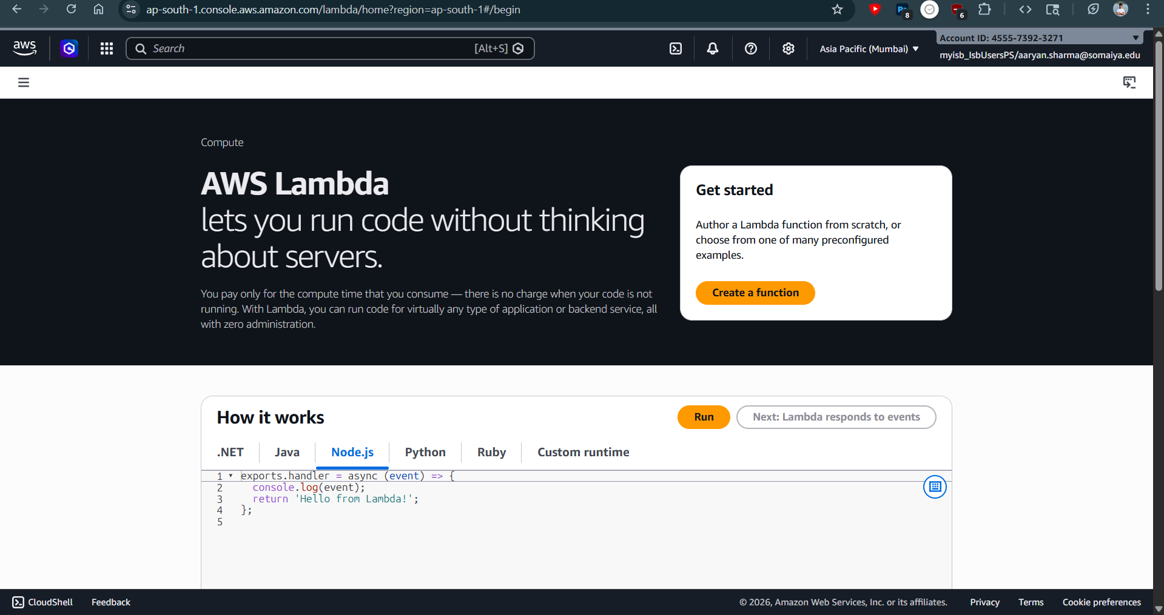
AWS Lambda dashboard
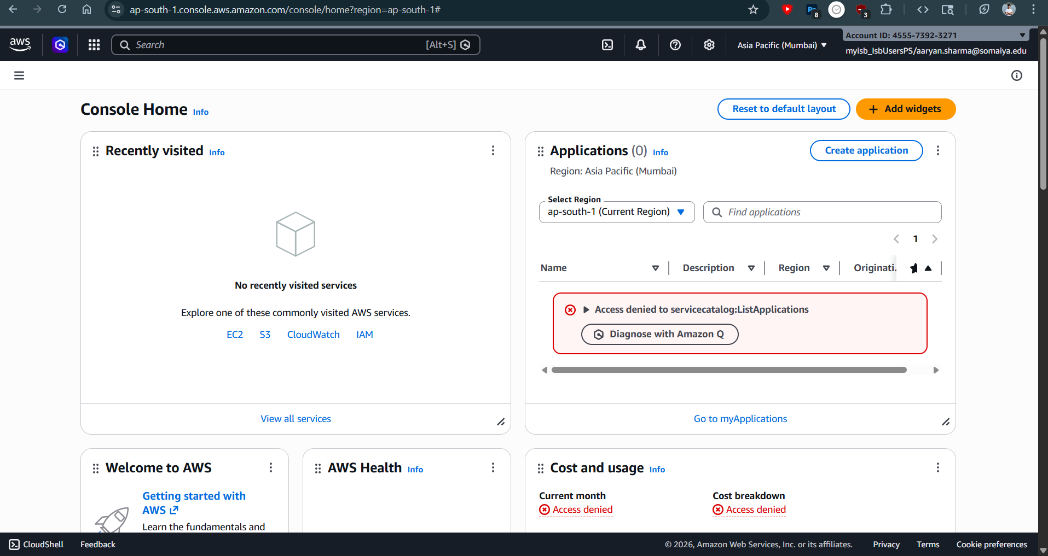
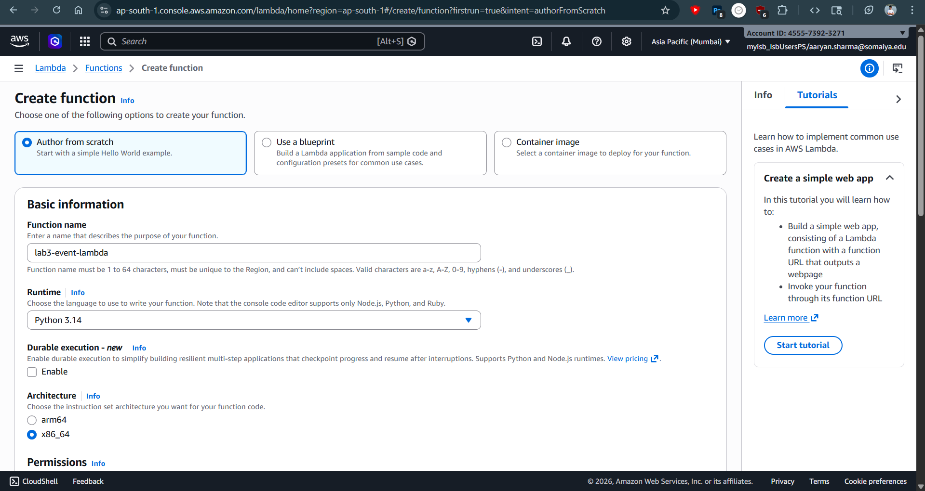
Creating a function in lambda
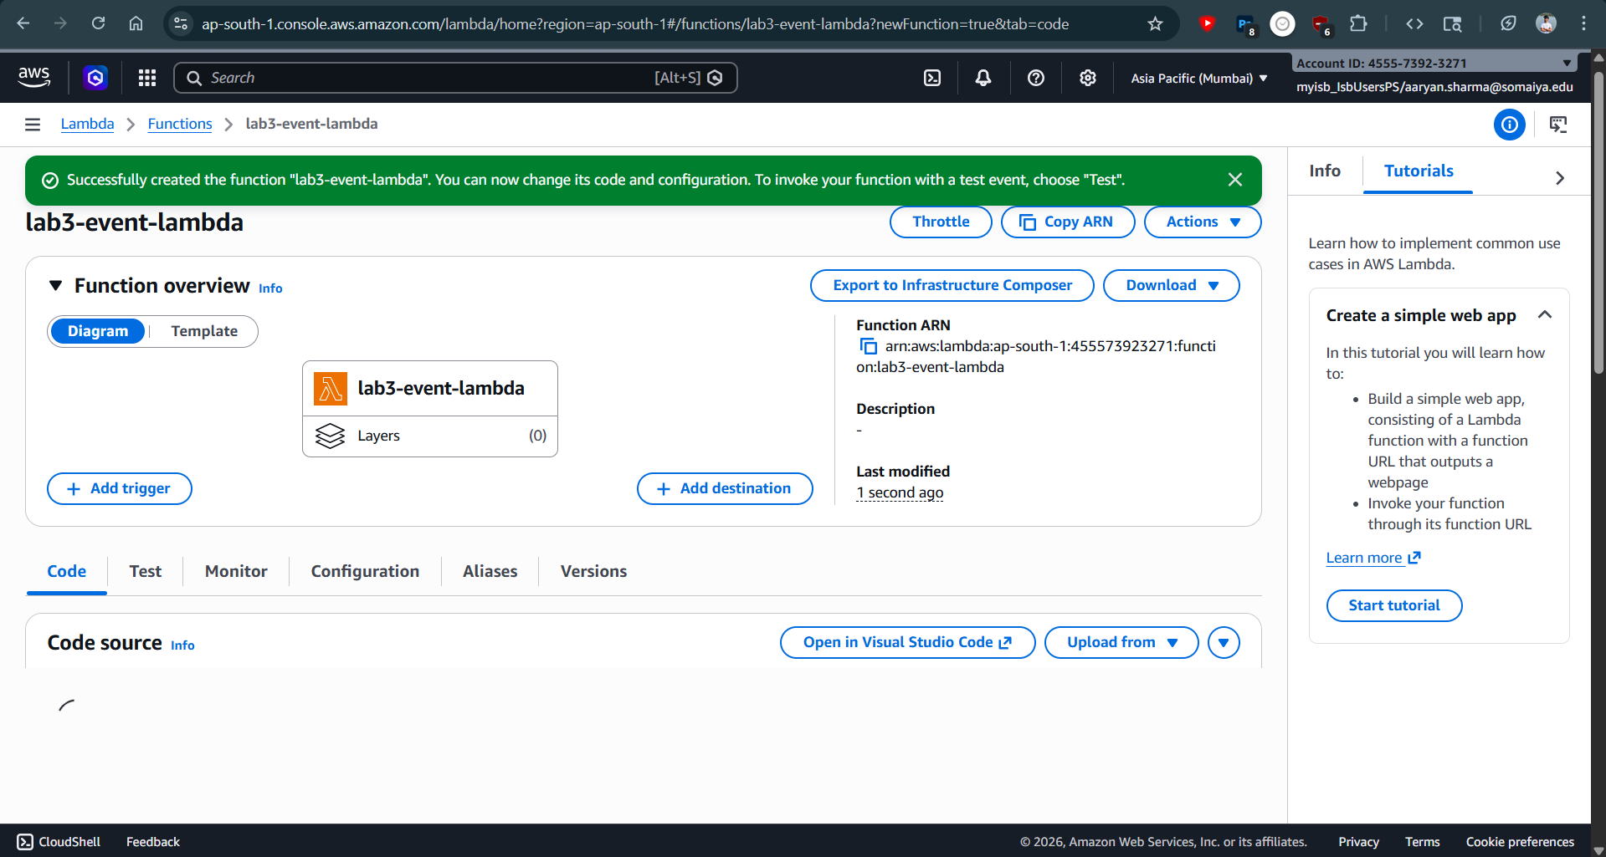
Successful creation of the lambda function
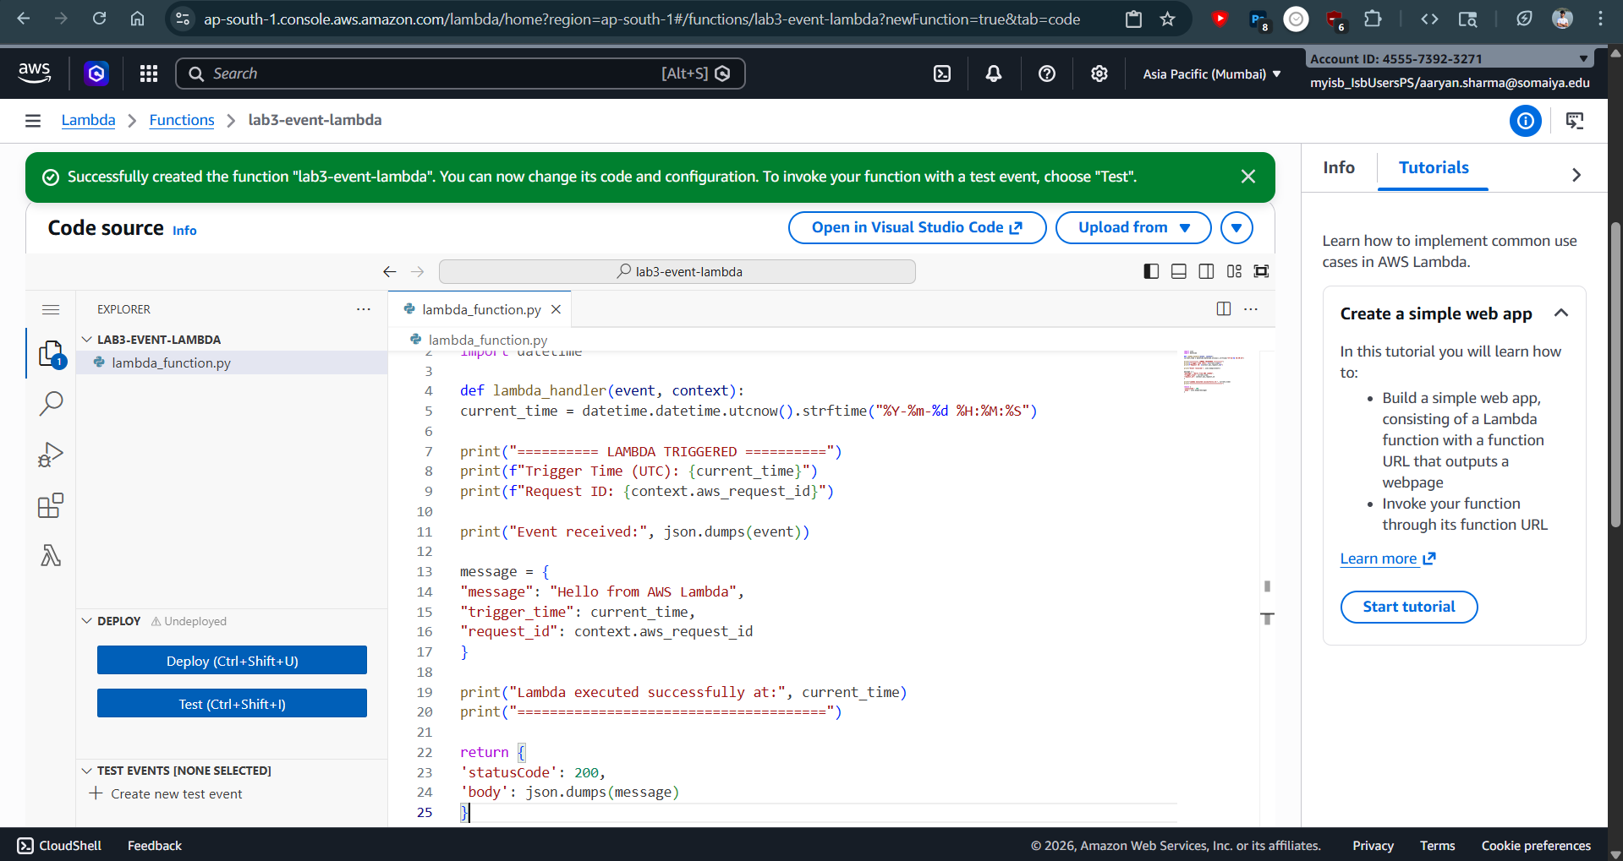
Deploying the code for lambda function
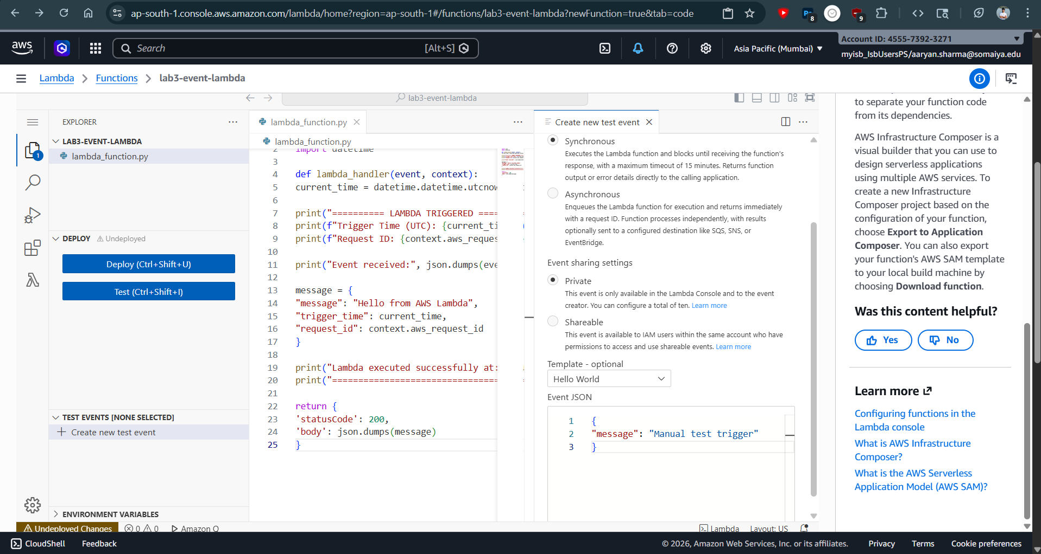
Creating Test Event
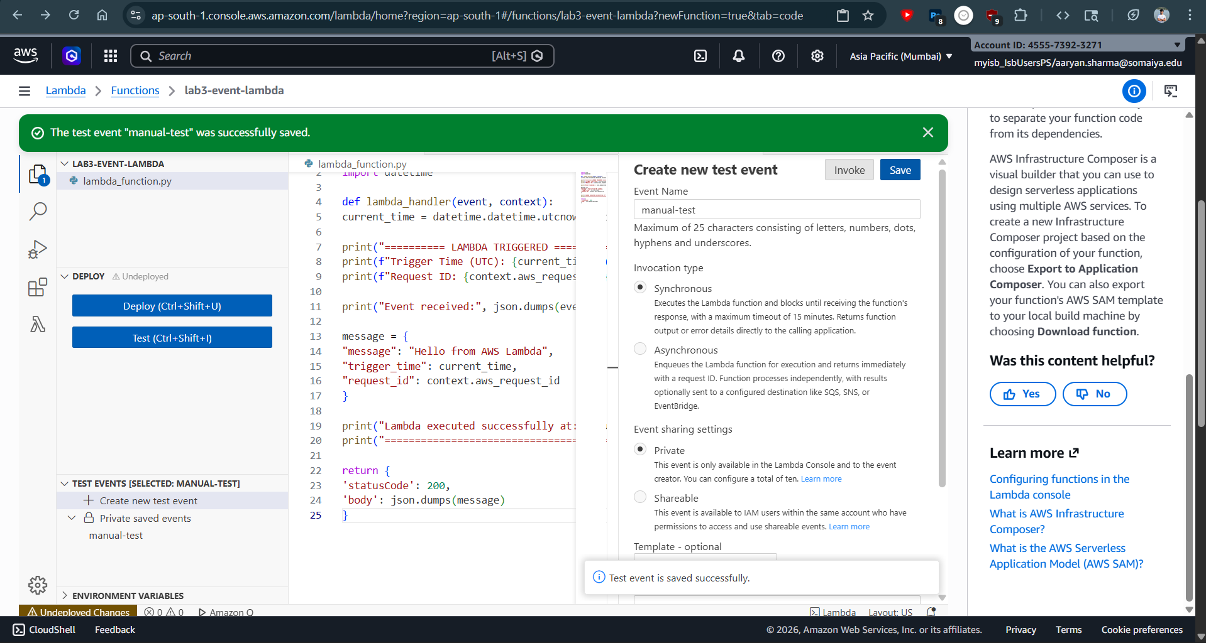Successfully creating the test event
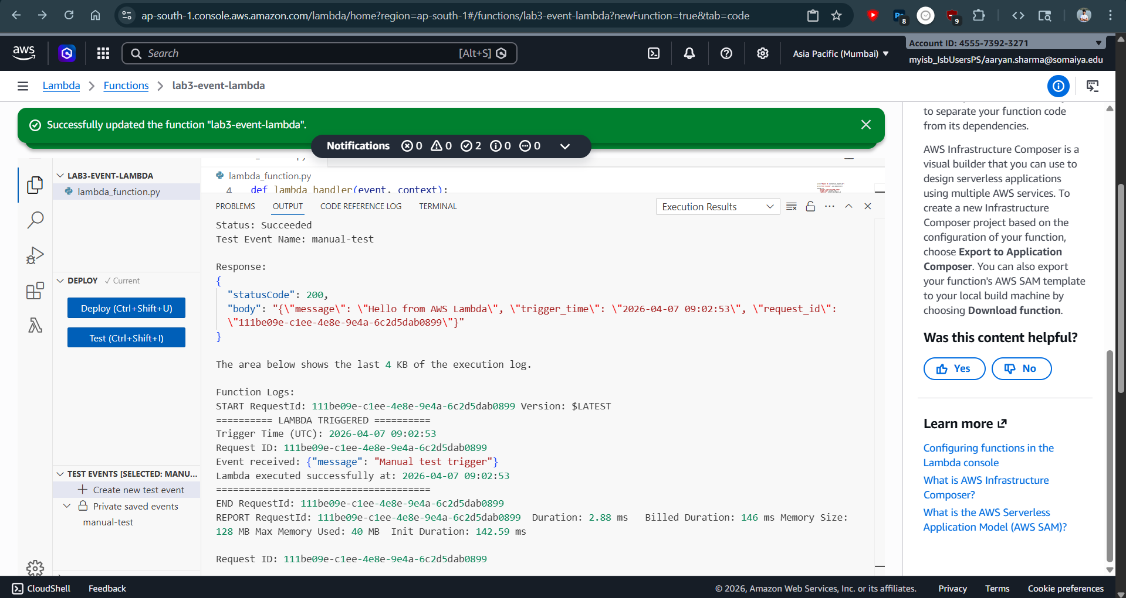
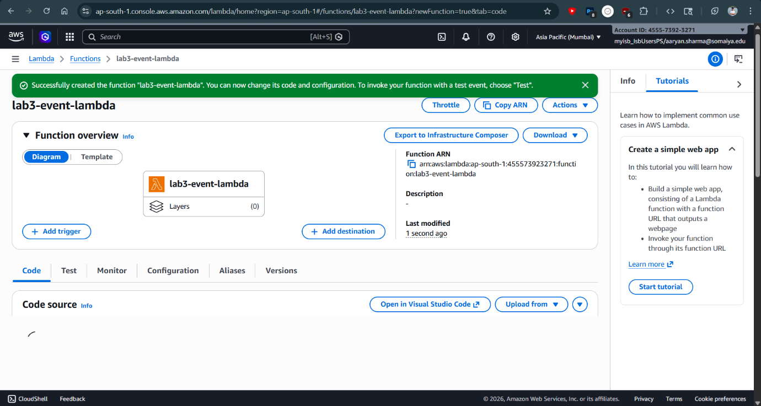Successful execution of Lambda function using test event
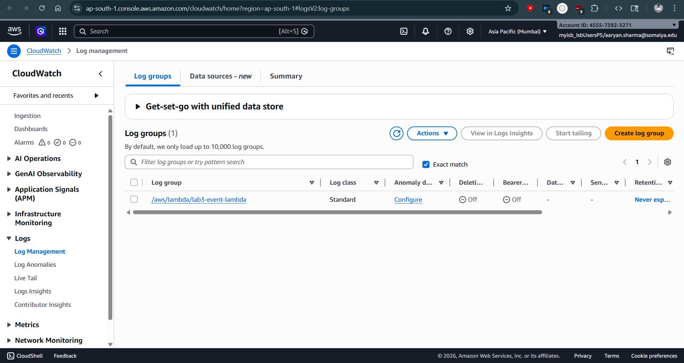
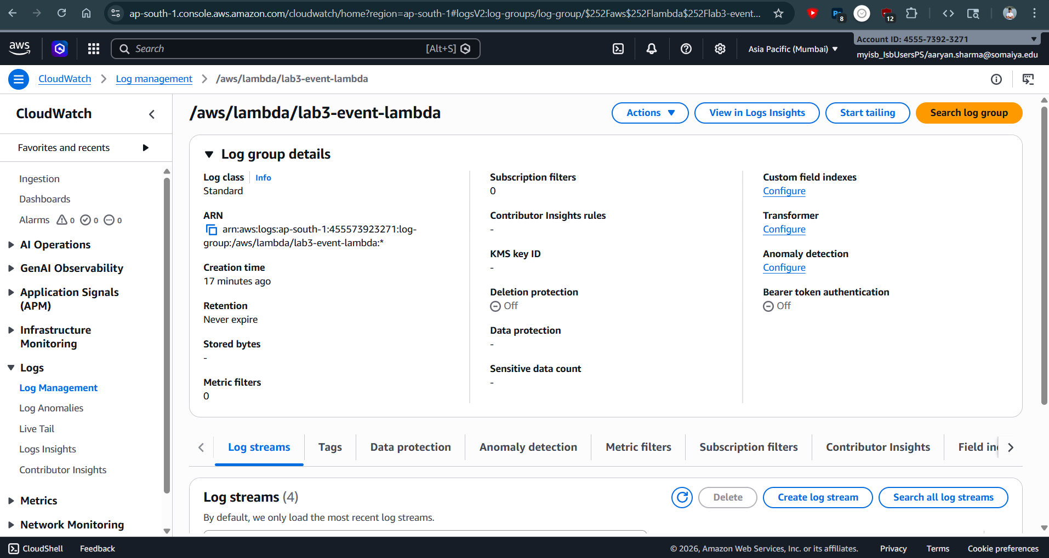
Viewing Lambda execution logs using Amazon CloudWatch log stream

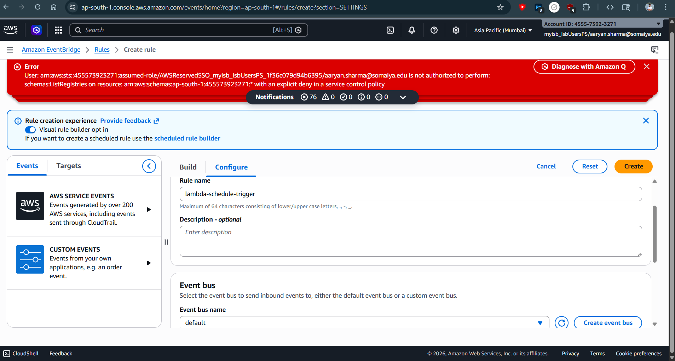
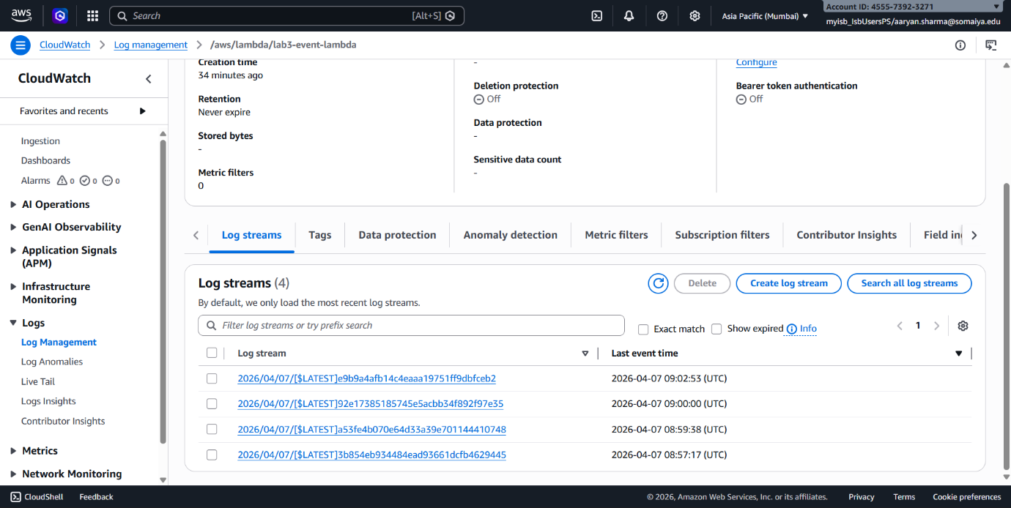
Viewing the logstream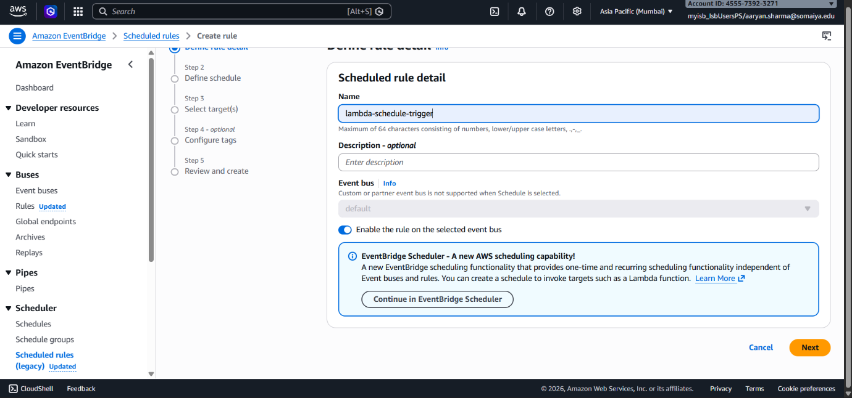
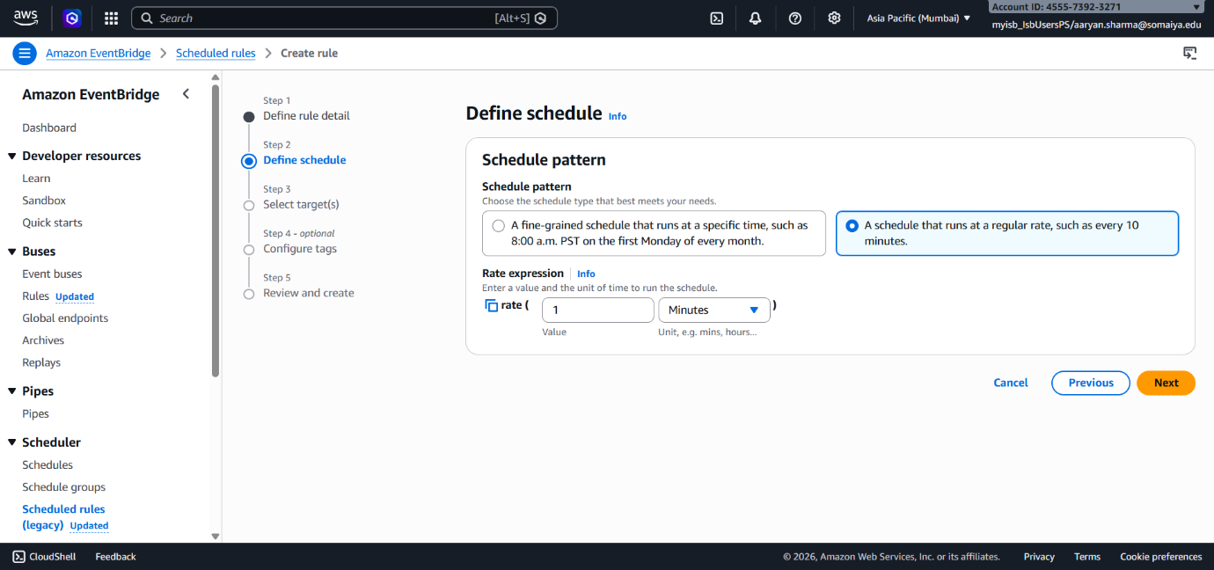
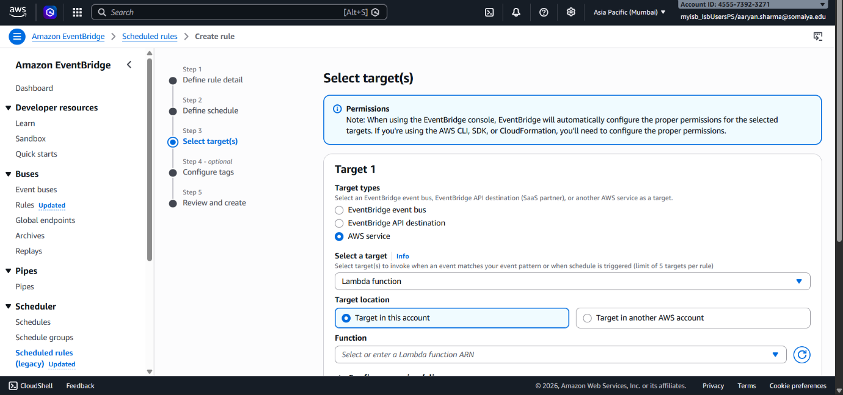
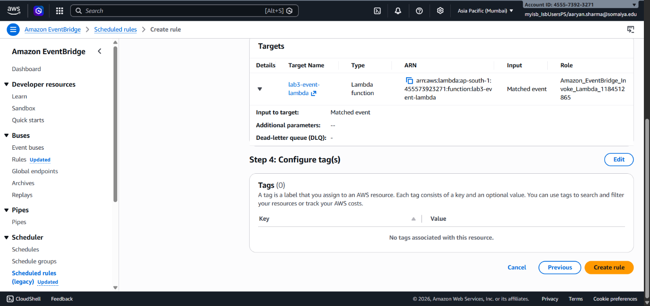
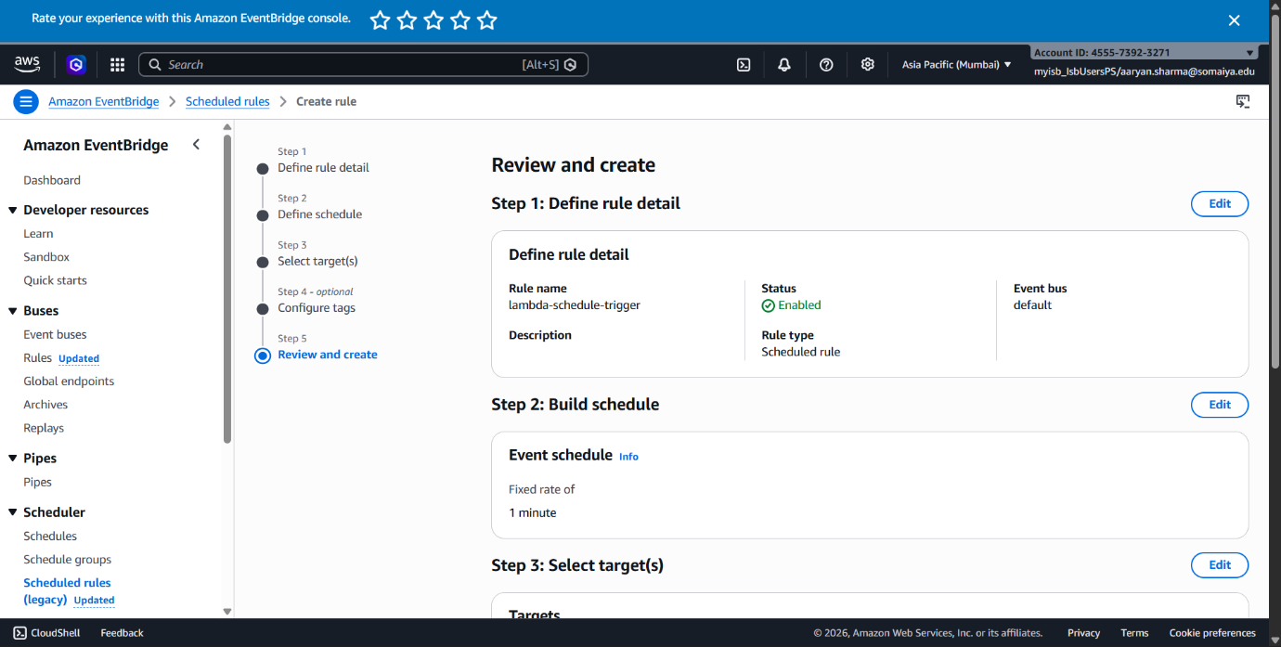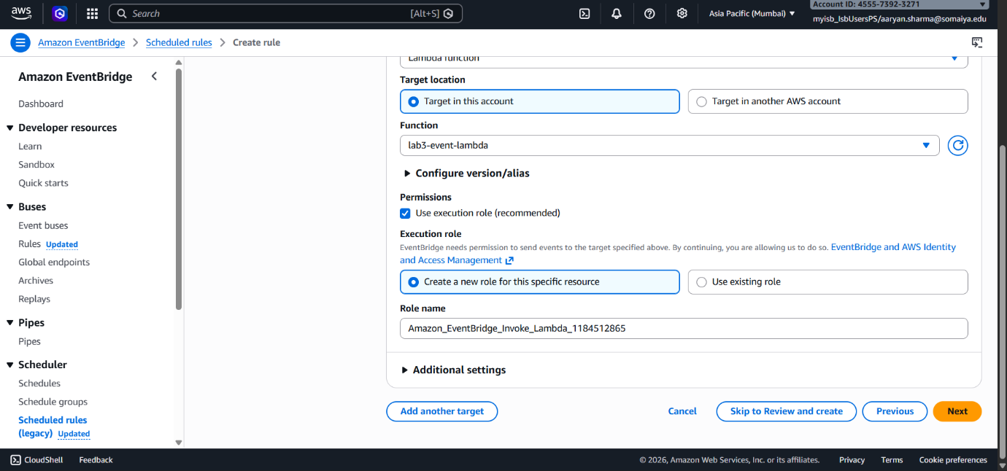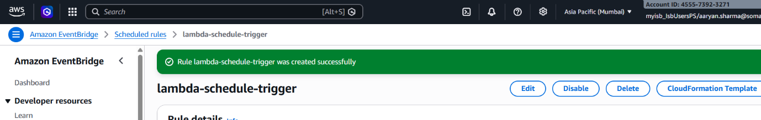
Successful creation of EventBridge rule
Conclusion: In this experiment, a serverless application was successfully implemented using AWS Lambda and Amazon EventBridge. A Lambda function was created and configured with appropriate runtime settings, and its functionality was verified through manual test events. An EventBridge rule was then created to trigger the Lambda function automatically at regular intervals, demonstrating event-driven execution. The execution logs were monitored using Amazon CloudWatch, providing insights into function performance and behavior. This experiment highlighted the advantages of serverless computing, including automatic scaling, reduced infrastructure management, and efficient execution of scheduled tasks in cloud environments.

